Oxford Fairgrounds

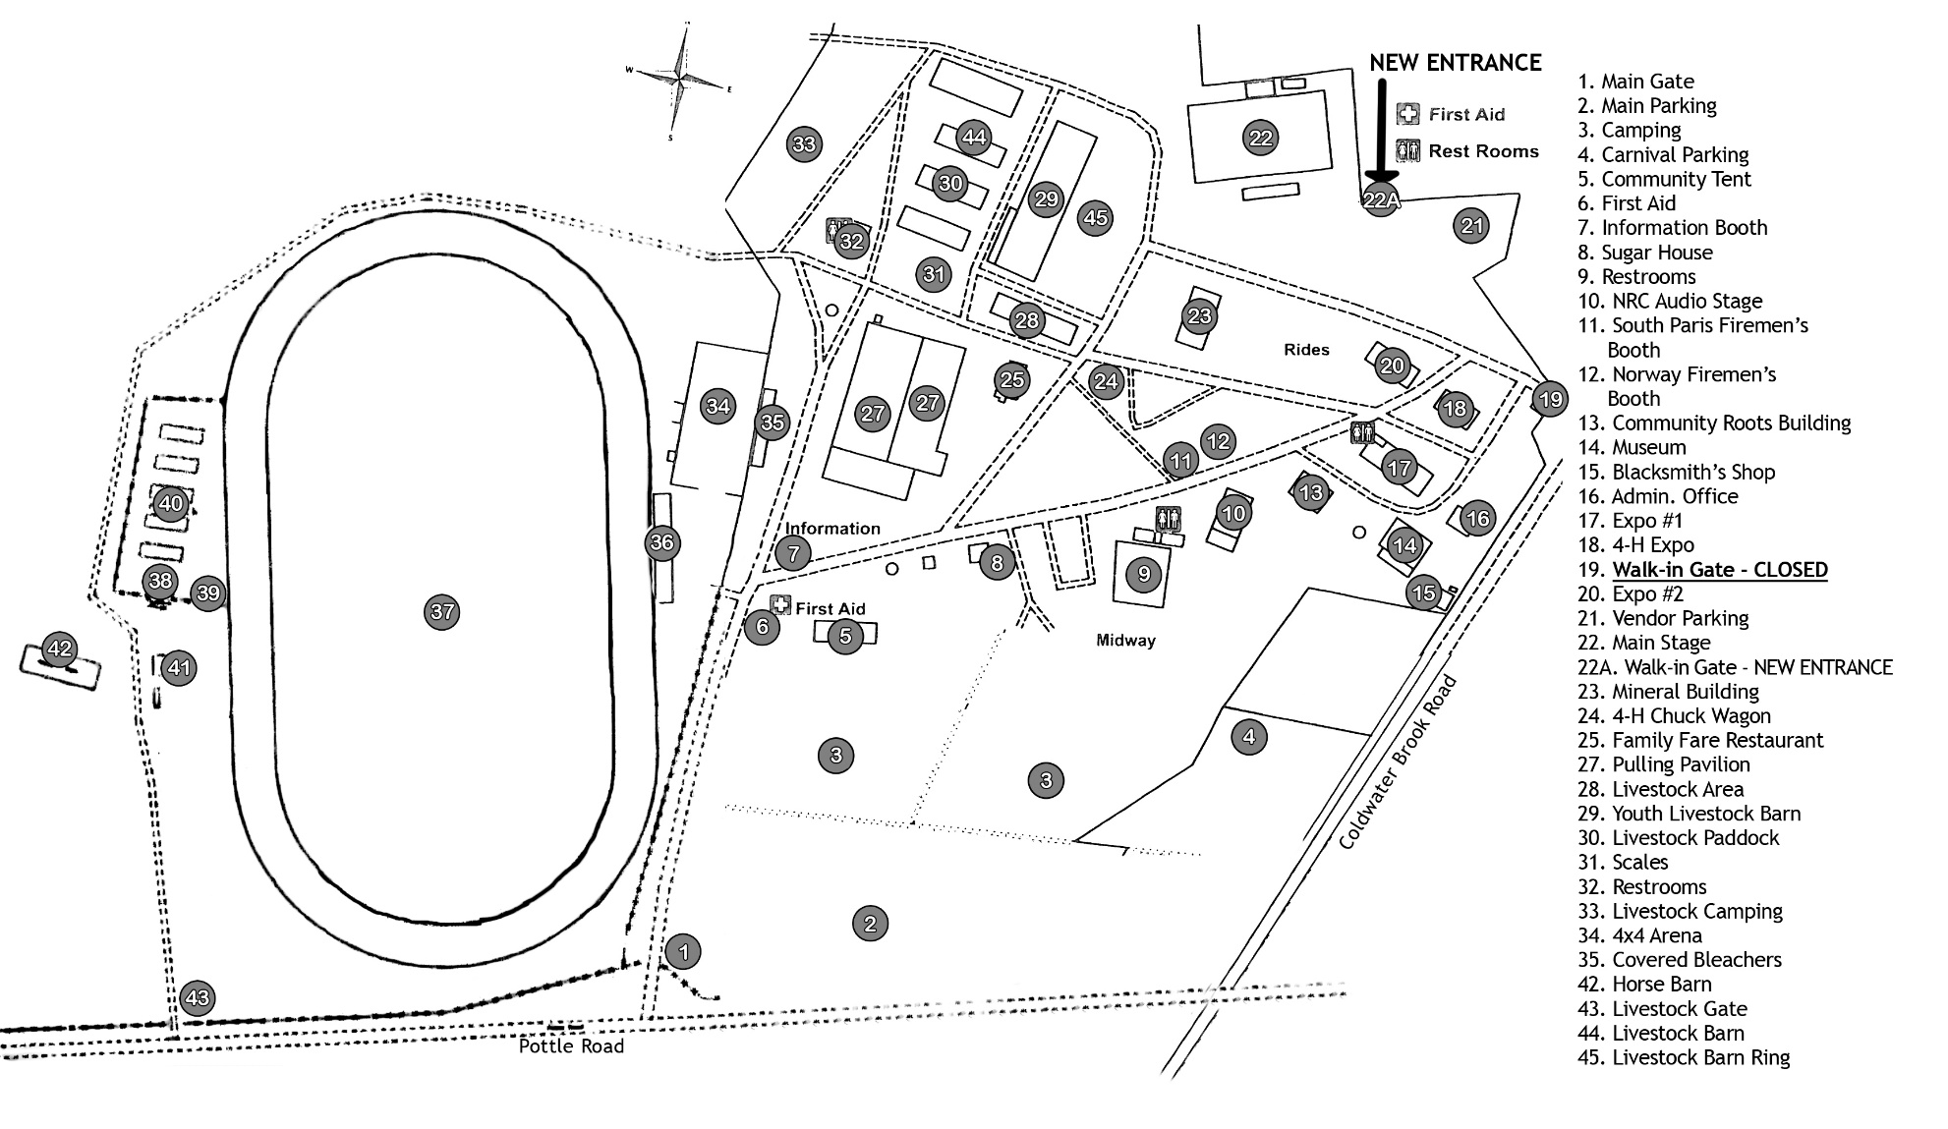

Rev: 08/2022

